

Joshua 1:9: Be strong and courageous. Do not be afraid; do not be discouraged, for the Lord your God will be with you wherever you go”

Document Title | Supporting Pupils with Medical Conditions Policy
Author/Owner  (Name and Title) | Nicky Bailey
Version Number | V3
Date Approved | March 2025
Approved By | LAAT Board

Policy Category  (Please Indicate) | 1 | Trust/Academies to use without amendment
Policy Category  (Please Indicate) | 2 | Academy specific appendices
Policy Category  (Please Indicate) | 3 | Academy personalisation required (in highlighted fields)

Summary of Changes from Previous Version
Version | Date | Author | Note/Summary of Revisions
V2 | March 2023 | Nicky Bailey | Complete re-write using template from ‘The Key’
V3 | March 2025 | Rachel Street | Review and update

Contents

1. Aims 4
2. Legislation and statutory responsibilities 4
3. Roles and responsibilities 4
4. Equal opportunities 6
5. Being notified that a child has a medical condition 6
6. Individual healthcare plans 6
7. Record Keeping 7
8. Managing medicines 7
8. Emergency Procedures 10
9. Liability and Indemnity 10
10. Complaints 10
11. Monitoring arrangements 10
12. Links to other policies 10
Appendix 1: Being notified a child has a medical condition 12
Appendix 2: Pupil individual healthcare plan 13
Appendix 3 : Parental agreement for setting to administer long term medication in line with IHCP 15
Appendix 3.1: Controlled Drug Record 16
Appendix 3.2: Record of long term medicine administered to an individual child 17
Appendix 3.3: Flow chart for administering long term medication 18
Appendix 4 : Parental agreement for setting to administer short term medicine 19
Appendix 4.1: Record of short term medication administered to an individual child 20
Appendix 4.2: Flow chart for administering short term medication 21
Appendix 5: Summary record of medicine administered to all children 22
Appendix 6: Contacting emergency services 23
Appendix 7: Record of medication required during educational visits 24
Appendix 8: Spillages of Medicines Recording Form 25
Appendix 9: Incorrect Administration of Medicine Record 26

1. Aims

This policy sets out our approach to supporting pupils with medical conditions across the Lincoln Anglican Academy Trust. The named person for implementing this policy at The Magdalen Church of England/ Methodist Primary School is Melanie Page.

This policy aims to ensure that:

- Pupils, staff and parents understand how our school will support pupils with medical conditions
- Pupils with medical conditions are properly supported to allow them to access the same education as other pupils, including school trips and sporting activities

The Trust Board will implement this policy by:

- Making sure sufficient staff are suitably trained
- Making staff aware of pupils’ conditions, where appropriate
- Making sure there are cover arrangements to ensure someone is always available to support pupils with medical conditions
- For EYFS pupils, at least one person who has a current paediatric first aid (PFA) certificate will be on the premises and available at all times when children are present and will accompany children on outings.
- Providing supply teachers with appropriate information about the policy and relevant pupils
- Developing and monitoring individual healthcare plans (IHPs)

The person with responsibility for implementing this policy is the Headteacher.

2. Legislation and statutory responsibilities

This policy meets the requirements under Section 100 of the Children and Families Act 2014, which places a duty on boards to make arrangements for supporting pupils at their school with medical conditions.

It is also based on the Department for Education’s statutory guidance on supporting pupils with medical conditions at school.

This policy also complies with our funding agreement and articles of association.

3. Roles and responsibilities

3.1 The Trust board

The Trust board has ultimate responsibility to make arrangements to support pupils with medical conditions. The Trust board will ensure that sufficient staff have received suitable training and are competent before they are responsible for supporting children with medical conditions.

3.2 The headteacher

The headteacher will:

- Make sure all staff are aware of this policy and understand their role in its implementation
- Ensure that there is a sufficient number of trained staff available to implement this policy and deliver against all individual healthcare plans (IHPs), including in contingency and emergency situations and
- Ensure that all staff who need to know are aware of a child’s condition
- Take overall responsibility for the development of IHPs
- Make sure that school staff are aware that they are insured to support pupils in this way
- Contact the school nursing service in the case of any pupil who has a medical condition that may require support at school, but who has not yet been brought to the attention of the school nurse
- Ensure that systems are in place for obtaining information about a child’s medical needs and that this information is kept up to date
- Make sure cover arrangements are made in the case of staff absence, and that supply teachers are briefed.

3.3 Staff

Supporting pupils with medical conditions during school hours is not the sole responsibility of one person. Any member of staff may be asked to provide support to pupils with medical conditions, although they will not be required to do so. This includes the administration of medicines. Any staff administering medicines MUST complete ‘handling medication in education’ course on Flick as part of their induction

Those staff who take on the responsibility to support pupils with medical conditions will complete ‘handling medication in education’ course on Flick and any other suitable training and achieve the necessary level of competency before doing so.

Teachers will take into account the needs of pupils with medical conditions that they teach. All staff will know what to do and respond accordingly when they become aware that a pupil with a medical condition needs help.

3.4. Further Training

Further training will be identified during the development or review of IHPs. Staff who provide support to pupils with medical conditions will be included in meetings where this is discussed.

The relevant healthcare professionals will lead on identifying the type and level of training required and will agree this with the headteacher. Training will be kept up to date.

Training will:

- Be sufficient to ensure that staff are competent and have confidence in their ability to support the pupils
- Fulfil the requirements in the IHPs
- Help staff to have an understanding of the specific medical conditions they are being asked to deal with, their implications and preventative measures

Healthcare professionals will provide confirmation of the proficiency of staff in a medical procedure, or in providing medication.

3.5 Parents

Parents will:

- Provide the school with sufficient and up-to-date information about their child’s medical needs
- Be involved in the development and review of their child’s IHP and may be involved in its drafting
- Carry out any action they have agreed to as part of the implementation of the IHP, e.g. provide medicines and equipment, and ensure they or another nominated adult are contactable at all times

3.6 Pupils

Pupils with medical conditions will often be best placed to provide information about how their condition affects them. Pupils should be fully involved in discussions about their medical support needs and contribute as much as possible to the development of their IHPs. They are also expected to comply with their IHPs.

Pupils managing their own needs

Pupils who are deemed competent by a health professional will be encouraged to take responsibility for managing their own medicines and procedures. This will be discussed with parents and it will be reflected in their IHPs.
Staff will not force pupils to take medication but will follow the IHP procedure and inform parents

3.7 School nurses and other healthcare professionals

It is expected that our nursing services will support the school and signpost for any relevant training to support the pupil’s medical need when a pupil has been identified as having a medical condition that will require support in school. This will be before the pupil starts school, wherever possible. They may also support staff to implement a child’s IHP.

Healthcare professionals, such as GPs and paediatricians, will liaise with the school’s nurses and notify them of any pupils identified as having a medical condition. They may also provide advice on developing IHPs.

4. Equal opportunities

Our school is clear about the need to actively support pupils with medical conditions to participate in school trips and visits, or in sporting activities, and not prevent them from doing so.

The school will consider what reasonable adjustments need to be made to enable these pupils to participate fully and safely on school trips, visits and sporting activities.

Risk assessments will be carried out so that planning arrangements take account of any steps needed to ensure that pupils with medical conditions are included. In doing so, pupils, their parents and any relevant healthcare professionals will be consulted.

5. Being notified that a child has a medical condition

When the school is notified that a pupil has a medical condition, the process outlined below will be followed to decide whether the pupil requires an IHP.
The school will make every effort to ensure that arrangements are put into place within 2 weeks, or by the beginning of the relevant term for pupils who are new to our school.

6. Individual healthcare plans

The headteacher has overall responsibility for the development of IHPs for pupils with medical conditions.

Plans will be reviewed at least annually, or earlier if there is evidence that the pupil’s needs have changed.

See Appendix 2.

Plans will be developed with the pupil’s best interests in mind and will set out:

- What needs to be done
- When
- By whom

Not all pupils with a medical condition will require an IHP. It will be agreed with a healthcare professional and the parents when an IHP would be inappropriate or disproportionate. This will be based on evidence. If there is no consensus, the headteacher will make the final decision.

Plans will be drawn up in partnership with the school, parents and a relevant healthcare professional, such as the school nurse, specialist or paediatrician, who can best advise on the pupil’s specific needs. The pupil will be involved wherever appropriate.

IHPs will be linked to, or become part of, any education, health and care (EHC) plan. If a pupil has SEN but does not have an EHC plan, the SEN will be mentioned in the IHP.

The level of detail in the plan will depend on the complexity of the child’s condition and how much support is needed. The Headteacher will consider the following when deciding what information to record on IHPs:

- The medical condition, its triggers, signs, symptoms and treatments
- The pupil’s resulting needs, including medication (dose, side effects and storage) and other treatments, time, facilities, equipment, testing, access to food and drink where this is used to manage their condition, dietary requirements and environmental issues, e.g. crowded corridors, travel time between lessons
- Specific support for the pupil’s educational, social and emotional needs. For example, how absences will be managed, requirements for extra time to complete exams, use of rest periods or additional support in catching up with lessons, counselling sessions
- The level of support needed, including in emergencies. If a pupil is self-managing their medication, this will be clearly stated with appropriate arrangements for monitoring
- Who will provide this support, their training needs, expectations of their role and confirmation of proficiency to provide support for the pupil’s medical condition from a healthcare professional, and cover arrangements for when they are unavailable
- Who in the school needs to be aware of the pupil’s condition and the support required
- Arrangements for written permission from parents and the headteacher for medication to be administered by a member of staff, or self-administered by the pupil during school hours
- Separate arrangements or procedures required for school trips or other school activities outside of the normal school timetable that will ensure the pupil can participate, e.g. risk assessments
- Where confidentiality issues are raised by the parent/pupil, the designated individuals to be entrusted with information about the pupil’s condition
- What to do in an emergency, including who to contact, and contingency arrangements
- A PEEP is in place where relevant

7. Record Keeping

Each school should maintain a secure file containing records of Pupils with Medical Conditions.
The Headteacher will ensure that written records are kept of all medicine administered to pupils for as long as these pupils are at the school.

IHPs are kept in a readily accessible place which all staff are aware of. Records protect staff and children and ensure agreed procedures are followed. They should be kept in line with the Trust data retention scheme

8. Managing medicines

Prescription and non-prescription medicines will only be administered at school when it would be detrimental to the pupil’s health or attendance not to do so, and only with parents’ written consent.
The only exception to this is where the medicine has been prescribed to the pupil without the knowledge of the parents.

Pupils under 16 will not be given medicine containing aspirin unless prescribed by a doctor.
Anyone administering medication (e.g., for pain relief) will check maximum dosages and the time of the previous dosage. Parents will always be informed.
The school will only accept prescribed medicines that are:

- In-date
- Labelled with the pupils name/details.
- Provided in the original container, as dispensed by the pharmacist, and include instructions for administration, dosage and storage
Insulin in a pen or pump may be accepted if in date.
All medicines will be stored safely. Pupils will be informed about where their medicines are at all times and be able to access them immediately. Medicines and devices such as asthma inhalers, blood glucose testing meters and adrenaline pens will always be readily available to pupils and not locked away.

Medicines will be returned to parents for safe disposal when no longer required, out of date or at the point where the pupil is leaving the school.

8.1 Controlled drugs

Controlled drugs are prescription medicines that are controlled under the Misuse of Drugs Regulations 2001 and subsequent amendments, such as ADHD medication morphine or methadone.
Current guidelines on controlled medications can be found here: List of most commonly encountered drugs currently controlled under the misuse of drugs legislation - GOV.UK

A secondary school pupil who has been prescribed a controlled drug may have it in their possession if they are competent to do so, but they must not pass it to another pupil to use. All other controlled drugs are kept in a secure locked cupboard in the school office or medical room.

Controlled drugs will be easily accessible in an emergency and a record of any doses used and the amount held will be kept.

Should a school trip require the administration of controlled drugs, then a member of staff should be allocated the responsibility for carrying the medication and ensure it is locked in their bag to restrict access. This staff member should be in the pupil’s group who requires the medication. The responsible person must ensure that the bag is never left unattended, or that it is locked within a room with restricted access for times that it is not needed.
They must follow the same procedures upon administration as would be expected within the school.
Completed paperwork should then be stored in the secure file containing records of Pupils with Medical Conditions upon returning.
These controls should also be documented within the risk assessment for the trip.

8.2 Accepting Medication
Medication should be given at home where possible. If administration at school is required, it will be scheduled according to pharmacy instructions, preferably during breaks or lunchtime to minimise disruption.
Children with long term medical conditions may require medication to be given on a regular basis and the school will ensure that staff who volunteer/or as part of their first aid role to give medication receive the relevant training to do this safely.

Short term medication should only be brought into the school if it is detrimental to the child’s health not to have the medication during the school day. Most antibiotics/other medication can be given around school hours and the Trust asks parents to ensure that they request antibiotics which can be given at home. Where antibiotics/other medication have to be given during the school day this will be done by a trained member of staff who has volunteered to give medication.

Parents must complete an authorisation form detailing the medication name, dosage, time, and administration procedure. The Head Teacher will decide whether it can administer the medication and inform parents accordingly.
Schools will not accept medication removed from its original container or altered in dosage, except for insulin in a pump or driver. Medication must be in the original packaging with prescriber’s instructions. Parents / Carers should bring all medicines to the school office, a nominated staff member will check medication upon receipt and ensure all forms completed and before administration.
Staff accepting medication must check the following information is present on the pharmacy label and complete approval has been given for medication to be administered:

- Name of child.
- Name of medicine.
- Dosage.
- Prescriber’s Instructions.
- Expiry date.
- Quantity provided.

NB: The label “To be taken as directed” does not provide sufficient information. Precise information must be supplied and cross checked with the child to the label.

Medication should be kept in in a secure fridge or locked medical cabinet not accessible to pupils.

8.3 Administering Medication
There will be two members of staff present at all times when any medication is administered. Staff will not be interrupted or approached to perform other duties whilst administering.
Before administration both staff should check.
Labels must include:
- Name of child
- Name of medicine
- Dosage
- Prescriber’s instructions
- Expiry date
Staff should complete the appropriate form after every dose of medication is given. Appendix 3 or 4 depending on type of medication. This record must be signed, dated and a time recorded. This record must be stored in the ‘medicines folder’. The ‘Record of medication given to all children’ form must also be updated Appendix 5. There is a shared responsibility between the school and parent to ensure that any medication provided to the school is in date and regularly checked by both the parent and school according to the needs of the medication and is line with the prescribed advice and any advice from the school nursing services

The child should not be forced to take the medication. Records must be maintained even if the child refuses the medication. Parents should be notified immediately of refusals. Emergency services should be contacted if necessary .

Spillages

Any spillages (including broken/dropped tablets) will be recorded, and parents will be informed.

7.4 Incorrect Administration of Medication
If an incorrect dose is given or the wrong medication is administered, parents and the Headteacher must be informed immediately. Medical advice should be sought via NHS 111. In serious cases, parents may be advised to take the child to a doctor or, if necessary, an ambulance may be called.
The incident must be logged on YMD Boon portal and reported to central team who will consider whether reporting to LADO is required
7.5 Unacceptable practice

School staff should use their discretion and judge each case individually with reference to the pupil’s IHP. Staff should seek advice from a medical professional or parental advice when in doubt. It is generally unacceptable to:

- Prevent pupils from accessing their medication when needed
- Assume all pupil with the same condition require identical treatment
- Ignore pupils’ or parents’ views
- Disregard medical evidence or opinion (though it may be challenged)
- Frequently send pupils home due to their condition or exclude them from activities unless stated in their IHP
- If the pupil becomes ill, send them to the school office or medical room unaccompanied or with someone unsuitable
- Prevent pupils from drinking, eating or taking toilet or other breaks whenever they need to in order to manage their medical condition effectively
- Require parents, to attend school to administer medication or provide medical support.
- Prevent pupils from participating in school activities or create unnecessary barriers,such as requiring parental accompaniment on trips
- Administer medications in inappropriate settings, such as the school toilets

8. Emergency Procedures

Staff will follow the school’s normal emergency procedures (for example, calling 999). All pupils’ IHPs will clearly set out what constitutes an emergency and will explain what to do.

If a pupil needs to be taken to hospital, staff will stay with the pupil until the parent arrives or accompany the pupil to hospital by ambulance.

9. Liability and Indemnity

The Board of Trustees will ensure that the appropriate level of insurance is in place and appropriately reflects the Trust’s level of risk.

10. Complaints

Parents with a complaint about their child’s medical condition should discuss these directly with the Headteacher in the first instance. If the Headteacher cannot resolve the matter, they will direct parents to the Trust’s complaints Policy.

11. Monitoring arrangements

This policy will be reviewed and approved by the Trust board annually.

12. Links to other policies

This policy links to the following policies:

- Accessibility plan
- Complaints
- Equality information and objectives
- First aid
- Health and safety
- Safeguarding
- Special educational needs information report and policy

Appendix 1: Being notified a child has a medical condition

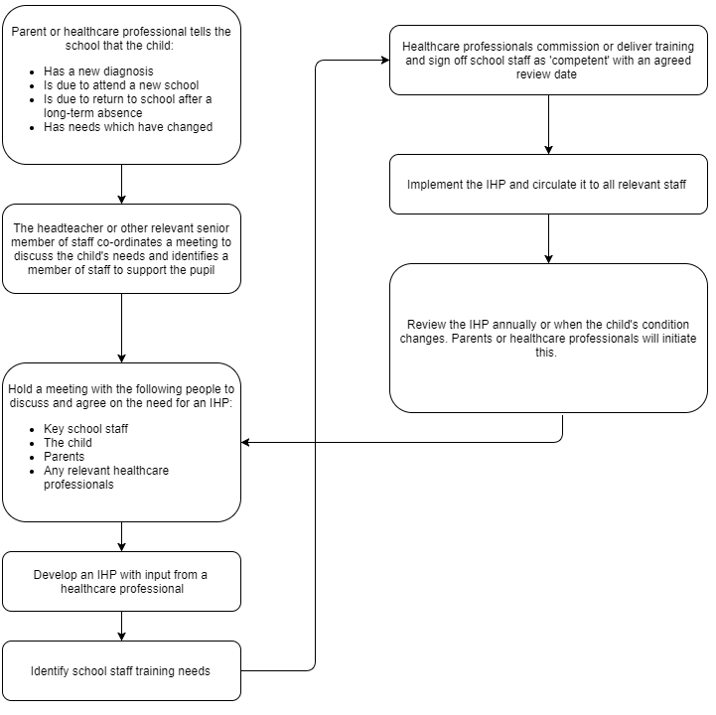

Appendix 2: Pupil individual healthcare plan

Name of school/setting
Child’s name
Group/class/form
Date of birth
Child’s address
Medical diagnosis or condition
Date
Review date
Family Contact Information
Name
Phone no. (work)
(home)
(mobile)
Name
Relationship to child
Phone no. (work)
(home)
(mobile)
Clinic/Hospital Contact
Name
Phone no.
G.P.
Name
Phone no.

Who is responsible for providing support in school

Describe medical needs and give details of child’s symptoms, triggers, signs, treatments, facilities, equipment or devices, environmental issues etc.

Name of medication, dose, method of administration, when to be taken, side effects, contra-indications, administered by/self-administered with/without supervision.

Daily care requirements

Specific support for the pupil’s educational, social and emotional needs

Arrangements for school visits/trips etc

Other information

Describe what constitutes an emergency, and the action to take if this occurs.

Who is responsible in an emergency (state if different for off-site activities)

Plan developed with

Staff training conducted by – health care professional. Detail staff trained, training received and date.

Staff Name | Professional – name and role | Training Received | Date

The above information is, to the best of my knowledge, accurate at the time of writing and I give consent to school/setting staff administering medicine in accordance with the school/setting policy. I will inform the school/setting immediately, in writing, if there is any change in dosage or frequency of the medication or if the medicine is stopped.

Parent Signature(s) Date

MIS Updated – completed by school.

Name | Date

Appendix 3 : Parental agreement for setting to administer long term medication in line with IHCP

Medication should be given at home where possible. If administration at school is required, it will be scheduled according to pharmacy instructions, preferably during breaks or lunchtime to minimise disruption.

You are required to complete and sign this form, authorising the school or setting to administer medication to your child.

Date for review to be initiated by
Name of school/setting
Name of child
Date of birth
Group/class/form
Medical condition or illness
Medicine
Name/type of medicine.
(as described on the container)
Expiry date
Dosage and method
Timing
Special precautions/other instructions
Are there any side effects that the school/setting needs to know about?
Self-administration – y/n
Procedures to take in an emergency
NB: Medicines must be in the original container as dispensed by the pharmacy.

Contact Details
Name
Daytime telephone no.
Relationship to child
Address
I understand that I must deliver the medicine personally to | [agreed member of staff]

The above information is, to the best of my knowledge, accurate at the time of writing and I give consent to school/setting staff administering medicine in accordance with the school/setting policy. I will inform the school/setting immediately, in writing, if there is any change in dosage or frequency of the medication or if the medicine is stopped.

Signature(s) Date

Appendix 3.1: Controlled Drug Record

Name of Child __________________________________ Date of Birth ________________________
Class __________________________________

Date and Time | Medication In | Medication Out | Running Balance | Initials of Staff Members

Appendix 3.2: Record of long term medicine administered to an individual child

Date
Time given
Dose given
Name of member of staff 1
Name of member of staff 2
Date
Time given
Dose given
Name of member of staff 1
Name of member of staff 2

Date
Time given
Dose given
Name of member of staff 1
Name of member of staff 2
Date
Time given
Dose given
Name of member of staff 1
Name of member of staff 2

Date
Time given
Dose given
Name of member of staff 1
Name of member of staff 2
Date
Time given
Dose given
Name of member of staff 1
Name of member of staff 2

Appendix 3.3: Flow chart for administering long term medication

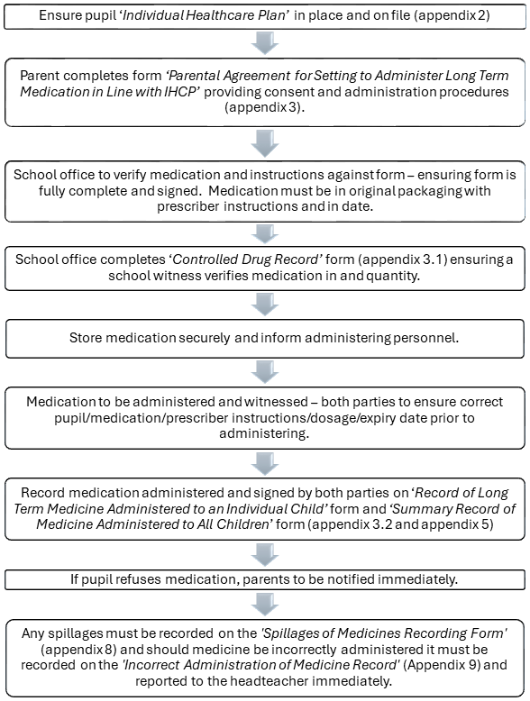

Appendix 4 : Parental agreement for setting to administer short term medicine

Medication should be given at home where possible. If administration at school is required, it will be scheduled according to pharmacy instructions, preferably during breaks or lunchtime to minimise disruption.

Short term medication should only be brought into the school if it is detrimental to the child’s health not to have the medication during the school day. Most antibiotics/other medication can be given around school hours and the Trust asks parents to ensure that they request antibiotics which can be given at home.

The school/setting will not give your child medicine unless you complete and sign this form, and the school or setting has a policy that the staff can administer medicine.

Date for review to be initiated by
Name of school/setting
Name of child
Date of birth
Group/class/form
Medical condition or illness
Medicine
Name/type of medicine.
(as described on the container)
Expiry date
Dosage and method
Timing
Special precautions/other instructions
Are there any side effects that the school/setting needs to know about?
Self-administration – y/n
Procedures to take in an emergency
NB: Medicines must be in the original container as dispensed by the pharmacy.

Contact Details
Name
Daytime telephone no.
Relationship to child
Address
I understand that I must deliver the medicine personally to | [agreed member of staff]

The above information is, to the best of my knowledge, accurate at the time of writing and I give consent to school/setting staff administering medicine in accordance with the school/setting policy. I will inform the school/setting immediately, in writing, if there is any change in dosage or frequency of the medication or if the medicine is stopped.

Signature(s) Date

Appendix 4.1: Record of short term medication administered to an individual child

Name of school/setting
Name of child
Date medicine provided by parent
Group/class/form
Quantity received
Name and strength of medicine
Expiry date
Quantity returned to parent
Dose and frequency of medicine

Staff signature

Signature of parent

Date
Time given
Dose given
Name of member of staff 1
Name of member of staff 2
Date
Time given
Dose given
Name of member of staff 1
Name of member of staff 2

Date
Time given
Dose given
Name of member of staff 1
Name of member of staff 2
Date
Time given
Dose given
Name of member of staff 1
Name of member of staff 2

Appendix 4.2: Flow chart for administering short term medication

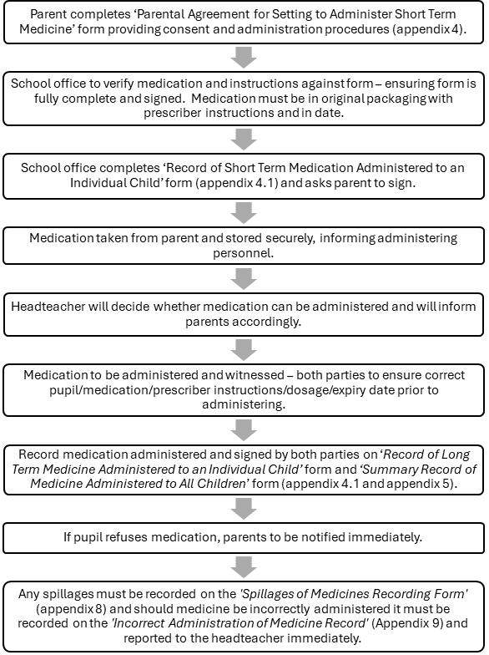

Appendix 5: Summary record of medicine administered to all children

Name of school/setting

Date Child’s name Time Name of Dose given Any reactions Signature Print name
medicine of staff

Appendix 6: Contacting emergency services

Request an ambulance - dial 999, ask for an ambulance and be ready with the information below.
Speak clearly and slowly and be ready to repeat information if asked.

- your telephone number
- your name
- your location as follows: The Magdalen Church Of Englang/ Methodist Primary School, Magdalen Road, Wainfleet PE24 4DD
- state what the postcode is – please note that postcodes for satellite navigation systems may differ from the postal code
- provide the exact location of the patient within the school setting
- provide the name of the child and a brief description of their symptoms
- inform Ambulance Control of the best entrance to use and state that the crew will be met and taken to the patient
- put a completed copy of this form by the phone

Appendix 7: Record of medication required during educational visits

Educational Visit:
Date:
Year Group/Class:
Child’s Name | Medication | Dose | Time | Medicine Packed

Appendix 8: Spillages of Medicines Recording Form

Name of Child
Class
Date
Medication
Amount Spilled
Parent/Carer Informed
Staff Name
Staff Signature
Staff Name
Staff Signature

Appendix 9: Incorrect Administration of Medicine Record

Name of Child
Class
Date
Medication
Amount Given
Parent//Carer informed/Action Taken
Staff Name
Staff Signature
Headteacher Name
Headteacher Signature
Further treatment received

